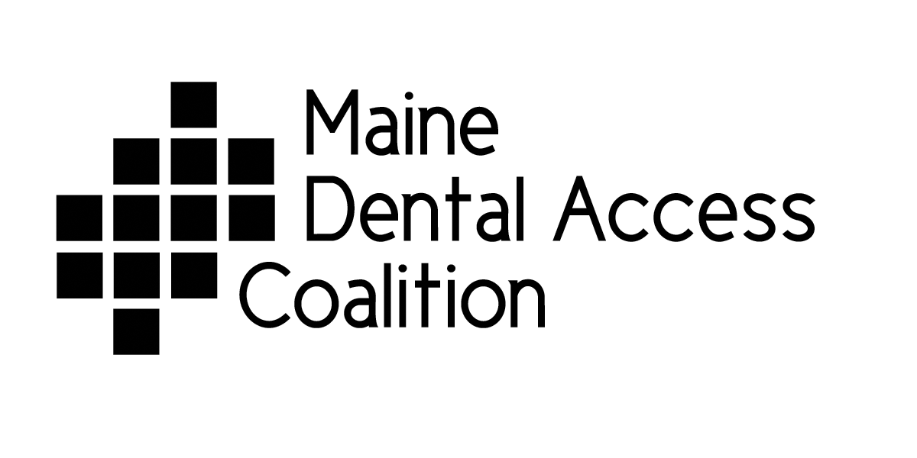
Governing Council Members July 2012

Wendy Alpaugh DMD, is a graduate of Tufts University School of Dental Medicine, and the General Practice Residency at Medical Center Hospital in Burlington, VT. She has been General Practice dentist in Stonington, Maine since 1982. She is the volunteer Clinical Supervisor at the UMA – Dental Hygiene School, as well as a regular volunteer at numerous GKAS clinics, annual dental screenings DISES. She is a member of the community health/school committee, the Maine Dental Association, where she has served on Executive Board , and President of the Hancock Dental Society, and consultant for the Downeast Dental Health Clinic. She was named an Oral Health Hero by the MDAC in the first year of those awards. She has served as Chair and Co-chair for the Coalition for many years.
Karin Anderson has more than 30 years of experience as a leader in the nonprofit arena. Before launching her consulting business in 2006, she served as Executive Director of the Maine Women’s Fund, which awarded $1.4 million in grants and initiated an innovative leadership program for young women during her 12-year tenure, the New Girls’ Network. Prior to moving to Maine in 1993, Karin worked with nonprofit organizations to build their organizational and fundraising capacities. Karin also organized two international conferences on philanthropy, which convened in 1988 and 1991. Karin currently serves on the boards of United Somali Women of Maine and the Portland Community Health Center. She also serves on advisory boards or committees of Planned Parenthood of Northern New England, Maine Initiatives, Community Financial Literacy, Goodwill Industries of Northern New England, and the Portland Performing Arts Festival.
Susan Cote, RDH, MS graduated from Forsyth School for Dental Hygienist and Boston University School of Dental Medicine with a Masters in Science in Dental Public Health. Her experience has been in private practice, public health and academic. Susan experience in public health has focused on integrating oral health into medical models and community-based programs in a variety of programs such as the the Program for Refugee Oral Health, Boston Medical Center Pediatrics, and City of Portand. Susan has also worked on international dental projects with Project Hope in Indonesia and Partners for Rural Health in the Dominican Republic. Currently, she is the Program Manager for From the First Tooth, an initiative that integrates early oral health prevention into medical setting throughout Maine.
Patricia Duguay is Executive Director of the River Valley Healthy Communities Coalition, part of the Western Maine Health District. She has served as director since the program’s inception in 1997. She is a public health professional with extensive experience in community outreach and partnership building. Prior to her current appointment, Patty was the Recycling Coordinator for the 6 town region of the Northern Oxford Regional Solid Waste, a reporter for the Advertiser Democrat, Rumford Falls Times and Sun-Journal, and worked as an Orthodontic Assistant. Other experiences include bookkeeping and banking.

Judith Feinstein, MSPH has been the director of the Maine CDC Oral Health Program since 1997. Her responsibilities include program management and development as well as monitoring legislation. Judy has been the project director for several federal grants including a current state oral health program infrastructure and capacity-building cooperative agreement from the US CDC. Judy has a bachelor’s degree in sociology from Beloit College and a master’s degree in public health from the University of Massachusetts. She has made numerous presentations on oral health issues in Maine at state, regional and national meetings. She serves on the Board of the Association of State and Territorial Dental Directors and chairs the Association’s Fluorides Committee. She co-founded the MDAC in 1997, and was recognized by the ME Public Health Association in 2000 with its Presidents Award for her work promoting improved access to oral health.

Elizabeth Graff is Practice Manager for the 19 dental staff and doctors working at the Jessie Albert Dental & Orthodontic Center in Bath, Me. Since 1990 she has worked with her husband orthodontist Dr Graff to direct, staff, and manage the financial side of the business until his first retirement in 2008. Before becoming the Practice Manger she has a background in retail and sales, including owning an interior design and custom accessories business in Vermont. The Jessie Albert Dental & Orthodontic Center, operated by Catholic Charities of Maine has given her the opportunity to share her talents and skills with others and to help people of all ages receive the dental care that they need to create a Healthier State of Maine.

Catherine J. Kasprak, CDA, RDH, AAS, PHS, IPDH graduated from Boston University, School of Graduate Dentistry as a Certified Dental Assistant, followed by completion of a Registered Dental Hygiene Pennsylvania State College of Technology. She has worked in a number of different dental specialty offices including periodontal, pediatric and public health over her 33 years in the dental hygiene field. Cathy was also instrumental in the creation of the Children’s Dental Program at the White Mountain Community Health Center in Conway, New Hampshire. She has held various positions within the Dental Hygiene Association at Local, State and National levels, and is the Maine Dental Hygienists’ Association’s Immediate Past President, having served 4 terms as President. In 2009 she received the MDHA’s RDH of the Year Award. She now runs the Bridgton Dental Hygiene Care, in Bridgton, ME.

Lisa C. Kavanaugh B.A., M.A. and M.B.A. is currently the Chief Executive Officer of Community Dental with administrative offices in Portland. Community Dental provides accessible and affordable oral health services to children and adults in dental health centers in Biddeford, Portland, Lewiston, Rumford, and Farmington. Community Dental provides oral care to approximately 22,000 children and adults. Additionally, Ms. Kavanaugh has over twenty five years of acute and psychiatric health care experience as a hospital administrator in both private, not for profit, and public hospitals. She is a Fellow in the American College of Healthcare Executives (FACHE) and lives in Winthrop

James J. Koelbl, D.D.S., M.S., M.J. Dr. Koelbl is the Founding Dean of the University of New England College of Dental Medicine. He previously served as Founding Dean of the Western University College of Dental Medicine in Pomona, California, and as Dean of the West Virginia University School of Dentistry. He has been an associate executive director of the American Dental Association and practiced general dentistry in rural and urban settings both full and part time for over twenty years. Dr. Koelbl served for seven years as a consultant to the Commission on Dental Accreditation and was appointed as a member of the Commission on Dental Accreditation. Dr. Koelbl also chaired the CODA Task Force charged with implementing recommendations made by American Dental Association House of Delegates. From 2005 through 2010, Dr. Koelbl served on the American Dental Education Association Legislative Advisory Committee, including a three years as Chair, where he helped develop the ADEA Principles of Health Care Reform. He has chaired the American Dental Education Association Task Force on the Education of New Oral Health Professionals.

Cindy Leavitt, RDH is the Founder and Director of Healthy Smiles for Maine, a non-profit that provides preventative and restorative dental care to children who otherwise couldn’t afford it in the Androscoggin area.

Timothy Oh, DMD is the Director and co-founder of Caring Hands of Maine Dental Center in Ellsworth and general dentist involved in community/public health oral health care. He has worked to increase access to care in Hancock and Washington counties by successfully launching school-based and portable outreach dental programs. Dr. Oh has been active with the MDAC and the MaineCare Dental Advisory Committee since 2008. He sits on the Maine Dental Association Executive Board and represents all New Dentists in the 6 New England states to the American Dental Association. Dr. Oh holds a DMD from the Arizona School of Dentistry & Oral Health, a Certificate in Public Health from UNC-Chapel Hill

Caroline B. Zimmerman, MPP: Works at the Maine Primary Care Association, and has been part of the Maine Dental Access Coalition since 2010. Through her role in community development, outreach and public policy for Maine’s Federally Qualified Health Centers, she has worked to improve access to comprehensive primary care, with a focus on oral health. for Maine’s Federally Qualified Health Centers, she has worked to improve access to comprehensive primary care, with a focus on oral health.
She participates on the Fluoridation Advisory Committee, and convenes MPCA’s dental director’s forum. Caroline’s programmatic expertise includes safety net policies and programs impacting access to care for the underserved. She received her undergraduate degree from Bowdoin College and Master’s in Public Policy from the Heller School for Social Policy and Management at Brandeis University.

