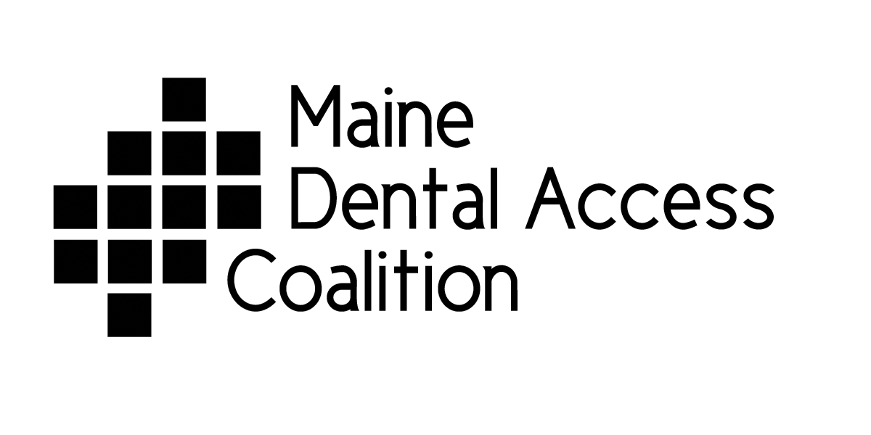Oral Care Services for Children in Maine

Pediatric Dentists
Dr Jonathan Shenkin | Augusta | (207)622-0303
Dr. Gaston To’olo | Bangor | (207)992-2152
Dr. Carey Fister | Brewer | (207)991-9580
Dr. Malcolm S. Foster | Brunswick | (207)729-5762
Dr Emily Scholl | Brunswick | 207-607-4197
Dr John Willis | Falmouth | (207)781-2272
Dr. Gary Creisher | Kennebunk SMMC | (207) 985-2800
Dr. Linda Eberhardt | Lewiston B St Clinic | (207)753-5400
Dr Audrey Stack | Portland | (207)874-1028
Dr. Susan Russell-Collett | Portland | (207)772-4111
Dr Mark Lucier | Sanford | (207)324-0026
Dr Michael McCoy | Scarborough | (207)883-4203
Dr Stephen Mills | Scarborough | (207)883-4203
Dr. Whitney Wignall | Portland | (207)773-3111
Oral Health Clinics
B. Street Dental Program | Lewiston | 753-5400
Bucksport Dental Center | Bucksport | 469-2359
Bingham Health Center – Dental Clinic | Bingham | 672-3519
Caring hands of Maine Dental Center | Ellsworth | 667-6789
City of Portland Oral Health Division | Portland | 874-8450
Community Dental | Cumberland, York, Androscoggin,  Oxford & Franklin Counties | 875-1025
Downeast Health Services:  Maine Coast community Dental Clinic | Ellsworth | 667-0293
Waterville Community Dental Center | (Kennebec and Somerset Counties) | 872-8893
Eastport Health Care Inc | Eastport | 853-6001
Fish River Rural Health, Eagle Lake Health Center | Eagle Lake | 444-5973
Harrington Family Health Center | Harrington | 483-4502
Health Access Network Family Dental Care  Island Community Medical/Dental Services | Lincoln  Vinalhaven | 794-6700  863-2533
Jessie Albert Memorial Dental Center | Bath | 1.888.304.8020
Katahdin Valley Health Center | Millinocket | 723-6565
Kennebec Valley Family Dentistry | Augusta Area | 623-3400
Knox County Health Clinic Dental Program | Rockland | 594-6996
Penobscot Community Dental Center | Bangor | 922-2152 #4
Regional Medical Center at Lubec  Sebasticook Family Doctors | Lubec  Newport – Pittsfield – Dexter – Dover | 733-5541  368-5189 ext 249
Strong Dental Center | Strong | 684-3045
St. Apollonia Dental Center | Presque Isle | 554-5045
St. John Valley Dental Center  Wiscasset Dental | Madawaska  Wiscasset | 728-7557  882-4888
York County Community Health Care | Sanford | 800-965-5762
Dental Hygiene Schools

University College of Bangor Dental Hygiene Clinic | Bangor | 262-7872
University of New England | Portland | 221-4900
Preventive Dental Hygiene Programs

Maine Dental Health Out-Reach | Winthrop based | 377-7003
Tooth Protectors | Portable Dental Clinics Statewide | 513-1111
Saving Smiles  Smiles For Life, PA - Portable Dental Clinic | Central ME & Waldo Co  Somerset – Penobscot Kennebec | 445-2852  270-1454
Tooth Fairies (TFI) | Lewiston, Auburn & Oxford Hills Region | 754-8487
Tooth Fairies, Inc | Primarily Southwestern Maine | 998-3500
Washington County Children’s Program * | *Work through dental van and schools, no appointments from individuals | 1-800-545-0873
Independent Practice Dental Hygienists
Saulter Dental Hygiene Center | Waterville | 861-8080
Bridgton Dental Hygiene Care PA | Bridgton | 647-4125

Call MaineCare Member Services for help finding a dentist for MaineCare members July 2012
1-800-977-6740 also - Call 211 for referral help and www.211maine.org or go to http://www.insurekidsnow.gov/state/maine/maine_oral.html to search for dentists accepting MaineCare by location

